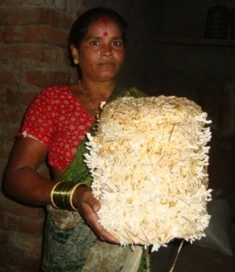
Mushroom production – A profitable enterprise
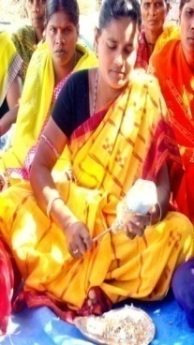
In the present era, farm women play a vital role in Indian agriculture. They are no more subordinate to their male counterpart but they rather complement them in their agricultural activities. The attention is always been focused on development of women in agriculture because there is much more opportunities for women to make themselves independent by engaging themselves in various agriculture related activities. Mushroom production is one of the activity in which rural women can get themselves involved and could add some capital to support their livelihood.
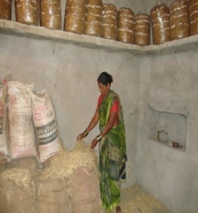
Ahalya Sahu a middle aged women from‘Malgaon’ village of Bhawanipatna block is truly been an example for her locality. Though she is a landless farm women but she had a strong desire to support her family by doing some income generated activities. During a field visit to her village, the officials of KVK, Kalahandi came to know about the interest of the farm women to make themselves self sufficient. The SMSs advised the farm women to go for mushroom production. As the village is near to the town so there will be hardly any difficulty to get the spawn and at the same time it will be easy for the marketing of the produce too.
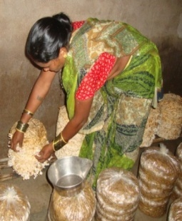
After getting the training on mushroom, she started with 1 or 2 beds, and after getting the result she thought that this can be a source of income to her family as it does not require much effort neither time consuming. Gradually she started putting more no. of beds and now in a year she puts more than 400 beds in oyster mushroom and 1000 beds in paddy straw mushroom. She is really been profited by this as it is home based enterprise, one does not need to go outside. It is very cost effective and does not require a big amount, which can be easily affordable by everyone. The B: C ratio of Paddy straw mushroom is 3:1 where as in Oyster is 4:1. Seeing the profit associated with this enterprise she has constructed a low cost shade house for mushroom production.
By practising this enterprise, she has earned a profit of around Rs.1, 14,000/- annually. Now she has become a source of encouragement for others in her locality. She has been recognized as a mushroom grower in the district. She feels herself proud being independent women managing her small family through her income and express that she will carry this enterprise and teaches other fellow women the method to cultivate mushroom. Seeing her success the women mass in her locality has also stared this enterprise. This technology has spread horizontally in almost all the district.

