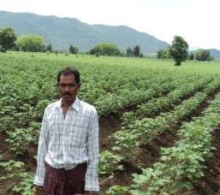
Integrated Pest Management -A Boost to Cotton production
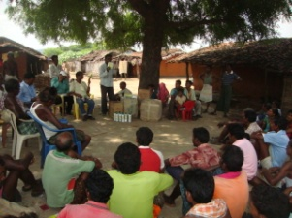
Cotton is a predominant cash crop grown in seven north-eastern blocks of Kalahandi district of Orissa. Cotton cultivable area of the district is 26 thousand, ha with average productivity of 10 qtl /ha. Due to favourable climatic condition and suitable soil type (black cotton soil) cotton is widely grown by the farmers of this region.
Brajabandhu Majhi resides in village Kubudi of Bhawanipatna block of Kalahandi district. He is 32 years old and the only earning member of his family has 7 acres of land out of which he cultivates cotton in 5 acres.
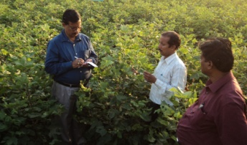
Heavy pest infestation and high cost of cultivation provides low return from cotton cultivation was the pressing problem of the cotton growers of Kubudi village.
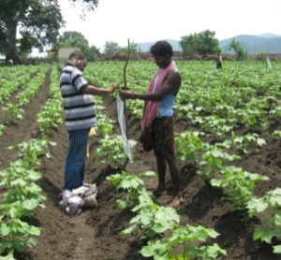
After gathering the information from the villagers about the serious problem of pest infestation in cotton crop, the experts from KVK discussed with the villagers on importance of integrated pest management in cotton.
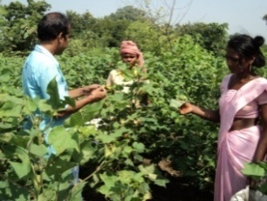
A training programme on integrated pest management in cotton was organised in the village by the experts. Cultural, mechanical, biological and chemical methods of pest management was practiced, such as treatment of seed with imidacloprid, planting of marigold around the cotton field as trap crop, installation of Pheromone traps @ 4 nos./ acre to monitor the activities of insectpest, spraying of Neem pesticide to manage the early season sucking pests and foliage feeders within 60 DAS, Spraying of Planofix (NAA) @ 10 and 20 ppm at 60 DAS and 80 DAS reduced the droppings of squares and buds etc.
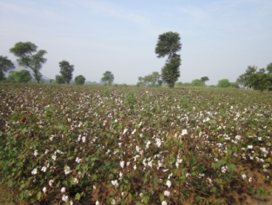
With the technical support and guidance of the KVK experts, IPM practices were applied on the cotton field. Previously the productivity of cotton was 12.5q/ha but after IPM practice the productivity has increased about 20q/ha. Now with an investment of Rs.20, 000/ha he could able to get a net return of Rs.60, 000/ha and the B: C ratio comes around 1:4. His annual income (cotton and other crops) is approximately Rs.1, 70,000/-. Villagers were happy to notice the remarkable changes in cotton yield.
He is a source of inspiration for other cotton growers. As day by day there is a high demand of cotton and proper marketing channel of the produce motivates the cotton grower to engage more no of lands in cotton production. Integrated pest management play a major role in the increasing the yield of cotton. Seeing the tremendous increase in cotton yield the other cotton growers are also interested in IPM practices in their field. Now not only he but the whole village is getting a bumper yield from cotton.

